### Overview

In this lab you will use Yahoo Finance as well as R to complete the exercise.

### Lab activities

Exercise 1: Getting R 3.3.3

### System requirements

|  |  |
| --- | --- |
|  | A Windows computer  32 / 64-bit Intel Processor  10 GB of Free Hard Drive Space  2 GB of RAM |

**Resources and References**

*[1] Learning Quantitative Finance with R – Param Jeet, Prashant Vats.*

| **Exercise 1: Support Vector Machine in algo trading** | |
| --- | --- |
| **Overview:**  The Support Vector Machine (SVM) is a type of supervised learning algorithm that can be used in regression analysis and classification problems. SVM relies on kernel methods. The kernels in SVM can be:   * *Linear* * *Polynomial* * *Radial* * *Sigmoid*   We show how SVM can be implemented in algorithmic trading strategies for indicating market trend. *Svm()* function from e1071 library is used. Thefunction has the following parameters: 1) type of support vector machine 2) kernel type 3) other parameters. The normalized in-sample out-sample data is used in the model. | |
| Install e1071 library | *install.packages("e1071",dependencies=TRUE)*  *library(e1071)* |
| Indicate isdir variable | *isdir<- direction[isrow]* |
| Normalize data | *osidn<- matrix(1,dim(osdji)[1],dim(osdji)[2])*  *norm_osdji<- (osdji - t(isme*t(osidn))) / t(isstd*t(osidn))*  *norm_osdji[,dm[2]] <- direction[osrow]* |
| Implement SVM model | *svm_model<- svm(norm_isdji,as.factor(isdir))* |
| Forecast the direction of out-sample data | *svm_prediction<- predict(svm_model,norm_osdji)* |
| Indicate the first few forecasted trends | *head(svm_prediction)* |
| Indicate osdir variable | *osdir<- direction[osrow]* |
| Indicate misclassification matrix | *table(svm_prediction, osdir)* |
| View the vectors generated by SVM | *svm_model$SV* |
| View the corresponding index values | *svm_model$index* |
| See the first few index values | *head(svm_model$index)* |
| See model coefficients | *svm_model$coefs* |
| Generate forecasts using the model | *svm_prediction* |

**Results**



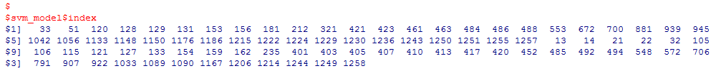



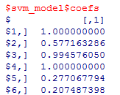

SVM provides forecasts regarding market trend

0 – downward trend

1 – upward trend

